Cambria Trust Newsletter May 2013 . No 41

From Cambria’s Wheelhouse
Since the January Newsletter we have had, along with many others, a very difficult time preparing SB Cambria for the new season’s work. Additional tasks were undertaken by Tim Goldsack and his team to be reported upon elsewhere.
This year we were fortunate to have the shipwright team wash off and antifoul Cambria’s underwater body.
Ian Ruffles with his crew Den and Reggie, and several of the volunteers rigged out the barge.
Painting was done as weather permitted, but thanks to the sterling efforts of Richard Weekes, who generally spent a couple of days in each week when the cold and wet allowed Cambria is looking pretty smart, still some paint jobs to do. Richard did the port rail capping just this week, between charters out of Gillingham, and continues his good work to great effect.
To date we have completed five charters; the first was a bare boat charter with ‘Sea Change’ in really appalling weather. Sea Change left the barge in the Medway, and we have sailed the other charters from Gillingham Pier. Three Young Carers week-ends supported by Rotary 1120, and most recently an Adult Rotary 1120 group, who followed a similar programme to the young people whom they have put so much energy into supporting. Their time aboard finished with an open day, on Bank Holiday Monday to enable other Rotarians to visit Cambria.
Gillingham Pier
Our introduction to working SB Cambria off Gillingham Pier has been much facilitated by our helpful and friendly neighbours.
The Medway Queen Preservation Society have a large yard and exhibition area with excellent workshop facilities and a large volunteer workforce. They will be bringing the Medway Queen back from Bristol to moor on the Pier later this year. Through the years the Society has been very helpful toward the Cambria Trust and we are indebted to their continuing help.
At the seaward end is a small industrial complex including a sail maker and a heating and engineering firm. During the week these places are manned and able to keep a weather eye on Cambria for us.
Cambria is mostly away on charter at the week-ends, so we have a fairly constant presence on the pier. There are also many helpful members of the public who are getting to know her there.
At the head of the Pier is Lightship 21, where a series of artistic and cultural schemes are run at frequent intervals.
So all- in- all we are grateful to our good neighbours, and hope our ship brings a little more interest to the area, which I’m sure she does.
Visitors at the weekend are often able to see a big sailing ship getting underway, and returning to the mooring.
This of course, brings back memories of when such ships were a common sight in the area.
It is hoped that we can become more organised to enable casual visitors to come aboard. This will be challenging due to the tidal range on the Pier.
The Pier will continue to be used by SB Cambria over the Medway Match week-end and a fortnight or so afterward. A visit to Gravesend is planned, but ferry operations from the outside berth of the Town Pier Pontoon makes managing Cambria very difficult.
Cambria Trust AGM 2013
This was held at London River House, on 21st April; our Thanks to PLA for use of this venue. The usual business was transacted, Captain Roy Stanbrook stood down as a Trustee with grateful thanks for his help and work during his time with us. He is currently serving in Gibraltar, as Harbour Master.
The other important business transacted was a change in the Charity’s objects, since we are now an operating vessel it requires a revision in our memorandum of association. This has been submitted to the Charity Commission and we await their reply.
My apologies to those who did not receive notice of AGM by e-mail; most were successfully delivered.
Winter Work
In the two weeks before Cambria started her work programme for the year several outstanding jobs were done by Tim Goldsack and his Crew:-
Central heating was fitted, running along the sides of the keelson and extending into the two heads with a radiator in each. This has proved very effective indeed, but there is still some finishing off to be done by way of protection for the pipework.
A two berth cabin was constructed adjacent to the main hold companionway. The bunks are dismountable so that the area can be a useful winter storage area. This will bring our capacity up to twelve passenger berths during the season.
Additional tankage for water has also been installed.
On deck: installation of the mast case winches was completed. These were present in Cambria’s former working days, and have proved to be very useful indeed. Hawse holes have been fitted in the saddle chock, these were also part of Cambria’s original fabric. Two extra hawse holes have been added forward of the fore horse to enable a better lead for the springs when moored.
While at Gillingham Pier all of these additions have proven to be very well worth having.
A few routine jobs; chaffing pieces for the leeboard pins, and strengthening plates on the windlass pawl- post knee have been completed.
All chores were still on-going a few days before her first charter, a stressful time for all involved particularly since the weather was still giving us a hard time.
Our Thanks to Tim and his team for their efforts under very difficult conditions during the winter.

Cambria. A Great Week-end by Dave Brooks
All things considered and wearing both my Cambria and Medway Barge Match committee hats it has been a great weekend. As Medway Surveyor (Medway Match Committee Boat) made her way across to the start line we hoped that the match might have the makings of a classic. Ten barges gathered of Gillingham Pier and were split into three classes. Staysail class was made up of two local barges Edith May (Lower Halstow) and ironpot Niagara (Hoo) and a second ironpot Repertor. The Bowsprit class was made of three ironpots, Cambria’s shipwright Tim Goldsack’s Decima, Adieu and the long awaited return to the Medway Match of Xylonite. Coasting Class was made up of Lady of the Lea, Orinoco, Ardwina and our own Cambria. The staysail class set off at 8.30 am with Repertor first across the line followed by Edith May and then Niagara. Next off was the Coasting class with the Lady of the Lea forcing herself by the Cambria and Orinoco and Ardwina and leaving them all scattered on the start with Cambria facing the wrong way down the river. Orinoco made a reasonable recovery and crossed second with Ardwina third and Cambria bringing up the rear some three minutes plus after the gun. The truly impressive starts came in the bowsprit class with Xylonite and Decima making a dash for the line. The committee poised to call foul as Xylonite kept coming, but she had judged it superbly crossing 7 seconds after the gun with Decima just seconds behind her. Adieu bringing up the rear but going like a train and soon passing both of them. With the committee boats starting duties over we set off after the fleet and the staysail barges had made a lot of ground already. Edith May and Niagara battled down river with Edith May leading them by Garrison Point. Repertor was at this stage a little out of sorts and trailing behind by some distance. Our Cambria had now made up for her awkward start and was keeping pace with the faster barges leaving her class mates in her wake. Adieu had flown by both Xylonite and Decima whom I suspect was trying to get to grips with her new bowsprit as she was way off the pace.
At the outer mark Niagara rounded the mark first with Edith May second and the Repertor catching up fast. Adieu made it by the outer mark first but Xylonite actually rounded first making lighter work of the still ebbing tide. Decima was third but sadly not challenging. I suspect she was having a private race with Orinoco skippered by another Cambria shipwright Geoff Ingle who at this point was having the better of it. Cambria rounded first in her class and 6th overall, way ahead of Lady of the Lea and Orinoco with Ardwina last of the barges round.
The race back proved to be the turn in fortune for the Repertor still trailing Niagara and Edith May. Niagara steamed back into the river a considerable distance ahead but Repertor ominously closed the gap and after some close sailing the lead changing hands several times edged by Niagara to win with Edith May third. Xylonite put in the fastest time of the day and overhauled every barge in the fleet bar Decima who was not having a good day, to finish first and fastest barge. Adieu came home second and Decima got the better of Orinoco eventually finished third. Cambria led the coasters home winning her second Medway Match and once again picked up the ‘Cambria Cup’ originally presented to her in 1928, well done to Skipper Ian Ruffles and crew Denis Johnson, Reggie Andrews and Stephen Hunt. Lady of the Lea stormed down Gillingham Reach to pip Orinoco for second and Ardwina had made up some ground and finished fourth.
The committee boat declared the race a fantastic day with all barges completing the full course out to the Medway Buoy and finishing. Xylonite was awarded the Seamanship Prize not only for her impressive start or rounding of the outer mark but also for her crews excellent handling of her sails which were always beautifully set. It was agreed that it was the best match we had seen for some time.
Cambria will be racing again in the Thames, Southend and Colne Matches.
The following day I joined the barge for a leisurely charter. Our party was made up of people who have helped Cambria enormously namely John Barber our rigger and his wife and Keith Adsley who helped with the outboard. Thank you to both. Also on board was Cambria Friend, esteemed historian and author Hugh Perks and local waterman Dick Norris. We had a good sail out into the estuary and where we managed to let Hugh, Keith and John have a turn on the wheel. We anchored for a while to have lunch and then Dick took a turn on the wheel as we returned to Gillingham. Dick coincidently owns Stormy Petrel once owned by legendary Cambria Skipper Bob Roberts.
Also out for a sail was our Basil Brambleby who was admiring the Cambria from his own beautiful looking boat Nancy May, he was admiring her so much, (I’ll whisper this so as not to embarrass him), he ran her aground and stayed there for several hours until the tide returned.
Our skipper showed his seamanship qualities by sailing Cambria into Gillingham Pier bringing her a few feet short of the quay, a round of applause was led by Hugh Perks and Dick Norris, high praise for a job well done. Everybody left the barge in a jovial mood having enjoyed the day, Thank you to All on board for a Great Day. So ends a fantastic week-end on Cambria.
** Iron Pot: name for a steel built barge.

On the following page a couple of interesting photographs of SB Cambria taken recently

Also a shot of the display cabinet aboard the barge in which are items for sale:
Cambria Story : £7.50
Mugs : £6.50 (two photos wrap around the mug)
Fridge magnets, pens, key rings: £ 1.50 each
Post cards : 0.50 each
SB Cambria restoration DVD: £10.00
Red Sails: £15.00

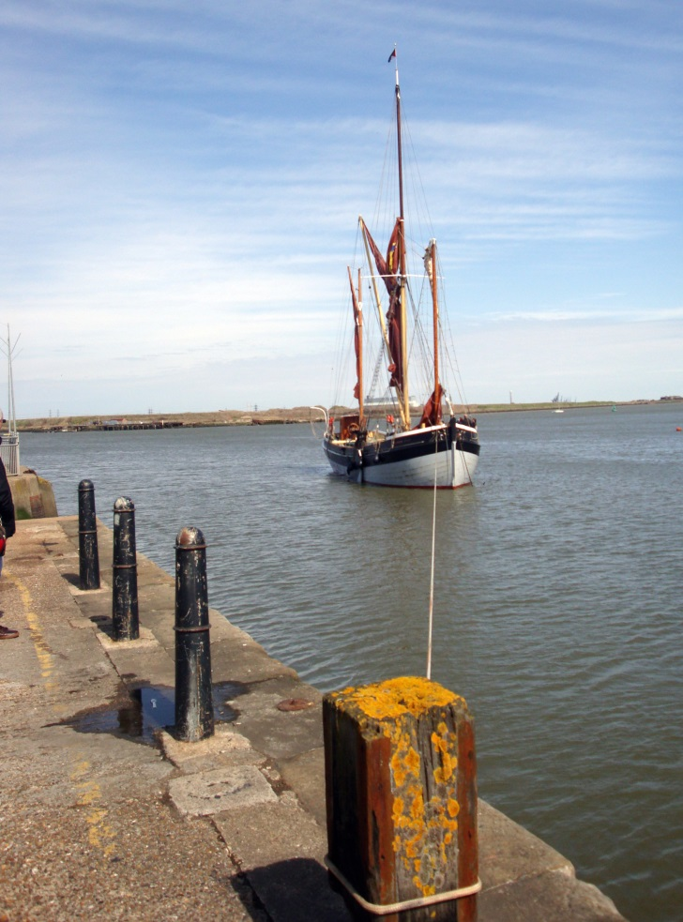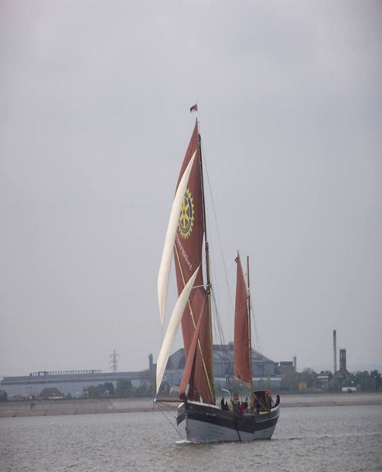
Cambria warping into Gillingham Pier Cambria sailing in the Medway Barge Match 2013

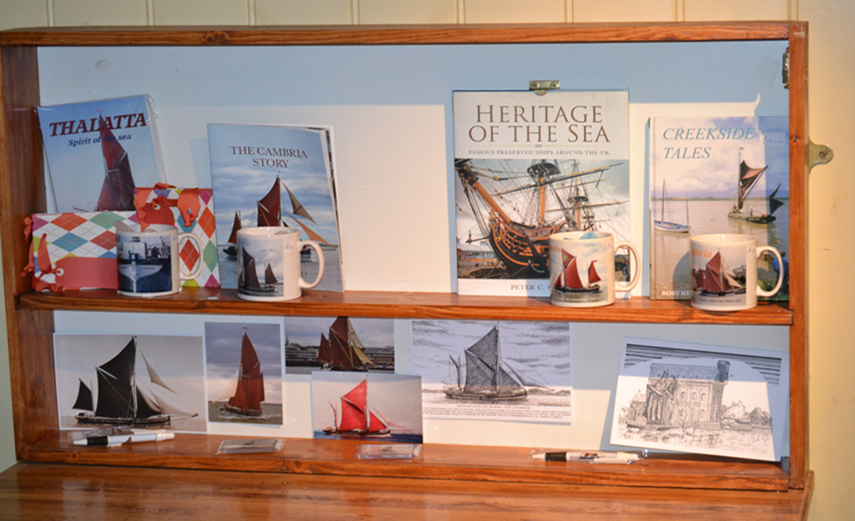
These Merchandise Items are available
- In the shop on line b) On board the barge c) Direct from Cathy Chapman.
There will be other items as time goes by.

Useful Information: Cambria Trust

SB Cambria Secretary: Dave Brooks, 15 Weybridge Close, Lordswood, Chatham ME5 8RW
e-mail: cambriatrustsecretary@live.co.uk

Treasurer: Chris Snelling, 118 Pixmore Way, Letchworth, Herts SG6 3TR

Membership Secretary: Cathy Chapman, 13 Beauvoir Drive, Sittingbourne, Kent ME10 2TQ

Cambria Trust Company Secretary:
Basil Brambleby, 32 Pilgrims Way, Cuxton, Kent ME2 1LG
Tel. No. 01634 710721
e-mail:cambriatrustsecretary@live.co.uk

Current subscriptions: Annual Subscription: £15. Senior Citizens: £7.50.

Please let me know if you have access to a computer, we will add your name to the e-mail address list
and keep you informed when the Newsletter is available via the website.
This helps us to keep running costs as low as possible whilst at the same time
keeping you up to date with latest Cambria happenings.
Thank you.

